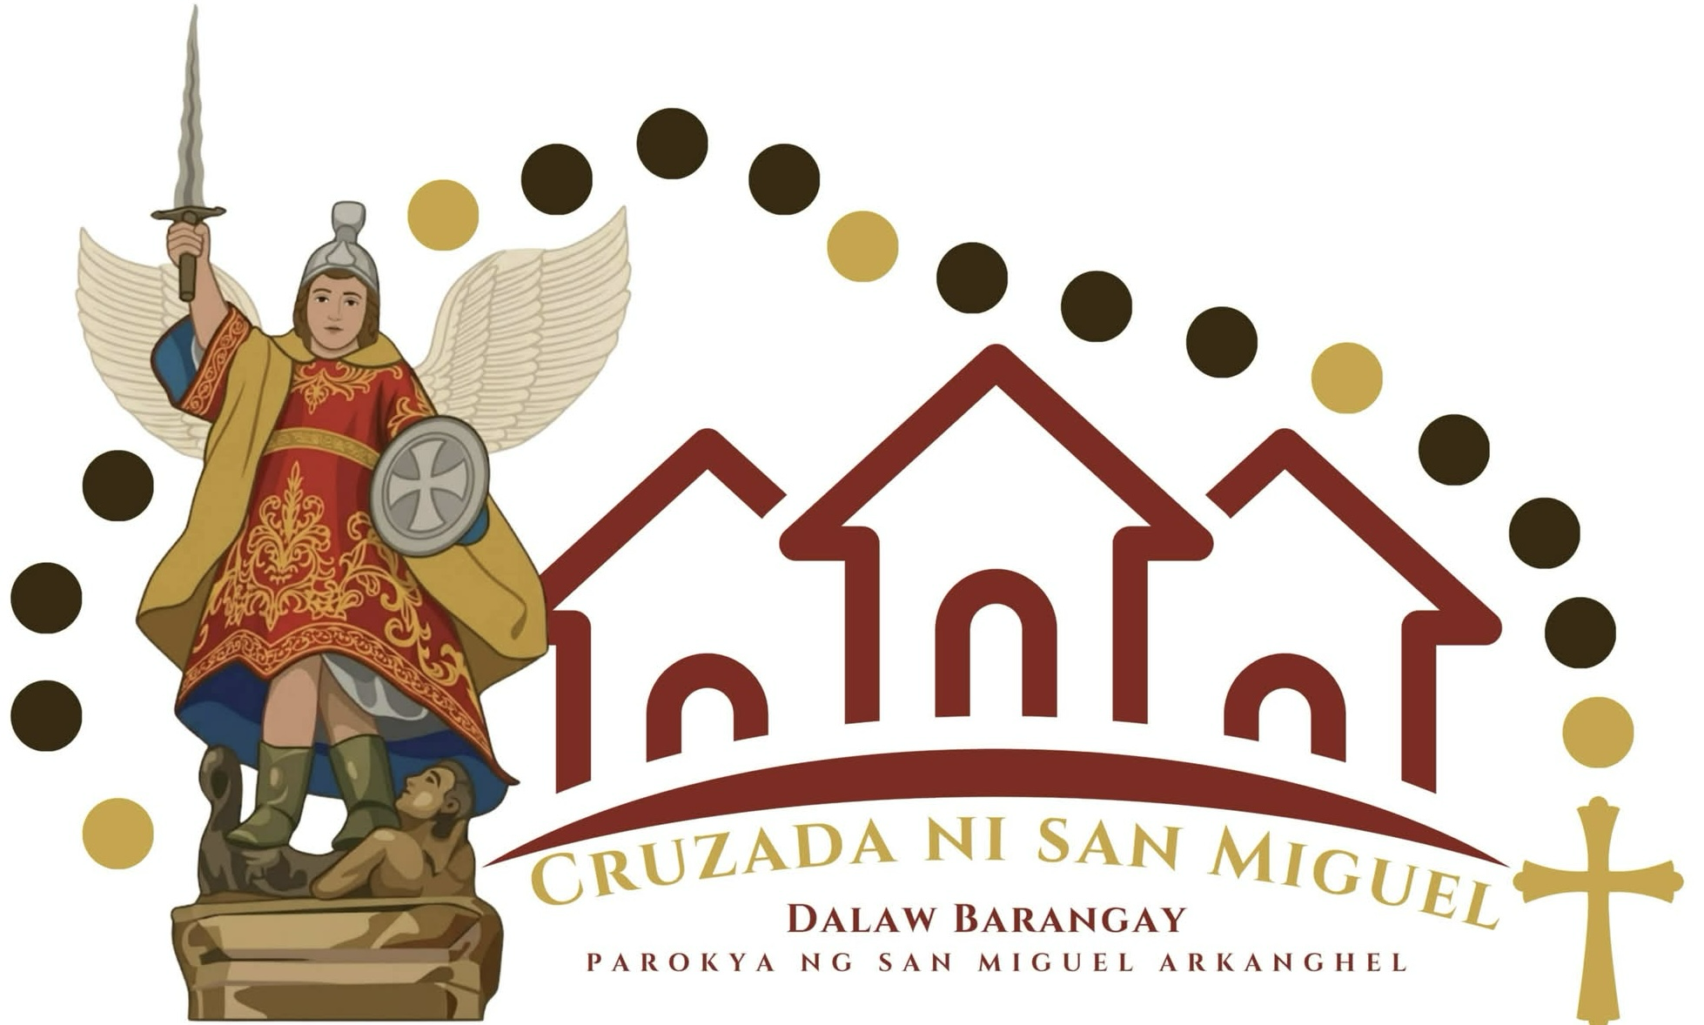

CRUZADA NI SAN MIGUEL

The year 2027 would be a year of jubilation and celebration for a little town parish situated in the eastern coastal part of the province of Bataan. In preparations for the 360th Founding Anniversary of the Parish of St. Michael in Orion, Bataan, the faithfuls of the said parish had launched a crusade that answers to the present need of the community, to rekindle the devotion to the Parish Patron Saint, St. Michael the Archangel.
It is “Cruzada ni San Miguel”.

Why is it called a “Cruzada”?

In the annals of history, a crusade is being launched by the Holy Roman Empire to expand its control in the conquered lands and to recover the Holy Land of Jerusalem, the place of birth and life of Jesus. It is known that Jerusalem was for a time placed under the reign of the Ottoman Empire which fosters the Islamic Religion. As an integral part of the Christian Faith, the Holy Roman Empire looked into a crusade, to gather the needed military power which will help in regaining the lost city of Jerusalem. This is the inspiration for the Cruzada ni San Miguel. As a community of faithfuls in this parish, they look into the guidance of the Patron Saint for launching this crusade. This crusade can be seen as a movement or a campaign in helping the community to re-discover the Catholic teachings and stories of the parish steadfast in faith.
This Crusade has a main objective in mind, which is to look again, with the eyes of faith, into St. Michael the Archangel and his importance in the present day battle.

What is “Cruzada ni San Miguel?

“Your enemy the devil is prowling like a roaring lion looking for someone to devour.” This verse in the first letter of Peter is very much still relevant in the present day.
There is still an ongoing battle in our community. It may not be a physical battle, more so, a spiritual battle, and we need spiritual favors and strength in order to overcome this struggle. The Parish Pastoral Council, under the guidance of the Parish Priest Rev. Fr. Abraham SP. Pantig and the Parochial Vicar, Rev. Fr. Jay Quicho, planned a weekly activity wherein the devotion to the Patron Saint, St. Michael would be rekindled. It is a barangay level parish visitation which includes different activities as planned by the Organizing Committee.

DAY 0-MARTES | PAGTANGGAP, PANALANGIN ,AT STATE OF THE PARISH ADDRESS
DAY 1- MIYERKULES | KATESISMO NG MGA ANGHEL AT CHAPLET NI SAN MIGUEL
DAY 2- HUWEBES | BIBLIARASAL
DAY 3- BIYERNES | PRUSISYON SA BARANGAY
DAY 4- SABADO | ARAW NG KABATAAN
DAY 5-LINGGO | “ARAW NG PANGINOON”
DAY 6- LUNES | KAPEHAN SA BARANGAY (MGA KUWENTO AT ALA-ALA SA PATRON SAN MIGUEL AT SA BAYAN NG ORION)
DAY 7- MARTES | MISA NG PAMAMAALAM, PAGLILIPAT SA SUSUNOD NA BRGY

It is a week-long activity that will be celebrated in each barangay of the town parish.

What are the objectives of this Crusade?
- Devotion to the Patron Saint, St. Michael the Archangel (Chaplet in honor of St. Michael)
- Devotion to the Word of God (Bibliarasal)
- Active Participation of all sectors of society into a unified crusade (Karakol)
- Revisiting the history of the Parish and Town of Orion (Kapehan sa Barangay)
- Re-encountering our faithfuls in the barrios of the Parish.
- Participation in the celebration of the Eucharist.

Cruzada ni San Miguel was launched last July 14, 2026 with a celebration of the Holy Eucharist and a procession going to the first barangay visit in San Vicente. It will be on a weekly transfer which will culminate on a Saturday activity before the Solemnity of Christ the King on November 22, 2026.

As we look forward to the Jubilee of 2027 for our town, may this endeavor allow us to re-visit and re-kindle the fire of devotion to St. Michael which will lead us into loving the heart of Jesus in the Eucharist.

